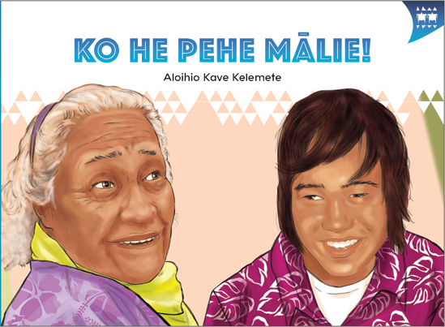
TEACHER SUPPORT MATERIALS TO ACCOMPANY:

Stories to Support the Pacific Learning Languages Series Resource
Muakiga! An Introduction to Gagana Tokelau

Ko he Pehe Mālie!
by Aloihio Kave Kelemete

Overview
These teacher support materials accompany the six storybooks developed especially to support the Learning Languages Series resource Muakiga! An Introduction to Gagana Tokelau. Each story gives students opportunities to extend their language and cultural knowledge and to practise reading the target language of specific units in Muakiga!
These teacher support materials suggest how teachers can use the six storybooks to foster gagana Tokelau learning at levels 1 and 2, particularly in the context of the Muakiga! programme.
The teaching-as-inquiry cycle and the Newton et al. research on intercultural communicative language teaching underpin these teacher support materials. See:
- the effective pedagogy section on page 35 of The New Zealand Curriculum
- the Newton et al.paper.

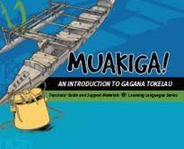
Muakiga! An Introduction to Gagana Tokelau
Muakiga! is a resource in the Learning Languages Series. It provides a language-teaching programme that can be used by teachers, including those who do not speak gagana Tokelau or know how to teach languages. Muakiga! includes:
- twenty units of three lessons each
- a range of language suitable for years 7–10 at levels 1 and 2 of the curriculum
- video and audio support to engage learners and demonstrate how fluent speakers use the language
- lesson plans that could be linked to opportunities for learners to enjoy reading
gagana Tokelau texts.
You can find Muakiga! online here.

Engaging students with texts
The teacher’s role is to mediate the interactions between the student and the learning materials and enable the student to meet their learning outcomes.

Ko he Pehe Mālie!
by Aloihio Kave Kelemete
This story supports Unit 9: Ko He ā te Kua Tupu? (What’s the Matter?) in Muakiga!

Learning goals
Encourage your students to set one or more of the following learning goals for their work with this storybook. The learning activities support these goals.
I will use gagana Tokelau to:
- read the story and understand it
- read the story aloud with clear pronunciation and reasonable fluency
- recognise and use some words and expressions in different contexts
- write texts with macrons and correct spelling
- talk or write about the story.
I will use English to:
- understand the story when it is read aloud
- talk about the content of the written and visual texts
- give examples of how Tokelau language and culture are organised in particular ways
- make connections with the language(s) and culture(s) I know
- research and present information about Tokelau culture and values in the story
- make connections with my learning in Unit 9 of Muakiga!

Language and Cultural Knowledge strands
The Language and Cultural Knowledge strands at levels 1 and 2 of Learning Languages in The New Zealand Curriculum require students to:
- recognise that the target language and culture are organised in particular ways
- make connections with known languages and cultures.
The language and cultural features of the written and visual texts in the storybook are described here.

(a) Language Knowledge
The language features of the written texts include:
- different verb forms, for example, fano / go (singular) and olo / go (plural); hau / come (singlar) and ōmamai / come (plural). Note that ōmai is an alternative plural form for ōmamai.
- use of hē to make negative statements, for example, Kua hē ia mafaia oi takalo lakapī. / He couldn’t play rugby.; … auā ko ia e hē hiva / … because he wasn’t dancing
- words transliterated from English, for example, Māti / March; lakapī / rugby; koniheti / concert; kītala / guitar; nofoa / sofa
- formulaic expressions, for example, Ko he ā te aho tēnei? / What date is it today?; Io, e hako. / Yeah, that’s right.; Manuia te pō! / Have a good time! [this evening]; Tōfā, koutou. / Bye, everyone.
- time expressions, for example, Aho Tōnai / Saturday; Ko te aho tolu o Māti. / It’s the third of March.; I te pō o te Aho Tōnai / On Saturday evening
- vocabulary and expressions associated with feelings, for example, fakanoanoa / sad; fītā / tired; fiu / bored; E pū! / How awful!; Oi auēkē, toku vae! / Ouch, my leg!; hāloa taku tama / my poor son
- vocabulary to express relationships, for example, tona tuagane / her brother; tona mātua tupuna / his [or her] grandmother; tona kāiga / his [or her] family
- different forms of pronouns to give precise meaning, for example, ki māua / us (dual); tātou / us (inclusive: all of you and me); koe / you (singular); koutou / you (plural, three or more)
- words with cognates in other languages, for example, fakalogologo / listen (compare with whakarongo (listen) in te reo Māori); patipati / clap (compare with patipati (clap) in te reo Māori and gagana Sāmoa)
- words of special cultural significance, for example, malae (lakapī) / (rugby) field, where malae has the meaning of an open space for recreation of a particular kind. In te reo Māori, however, the term “marae” is restricted to a communal or sacred place that serves religious and social purposes for the people who belong there.

(b) Cultural Knowledge
The cultural features of the written and visual texts include:
- the movement of people between Tokelau and New Zealand. Many settle in New Zealand permanently, and organise events where Tokelau people can meet and share their own culture. The Tokelau Easter Tournament is an example of this. This tournament takes place every two years in some part of New Zealand. Groups come from other countries to participate in the competitions, which include sporting events, as well as musical and dance events.
- the word māopoopo, which expresses the value of everyone being involved and included in the Tournament in different ways. Refer to page 9 of Gagana Tokelau: The Tokelau Language Guidelines for more explanation of this value. The word māfutaga (tournament) also expresses the idea of inclusion through its meaning of “gathering” or “fellowship”. The Easter Tournament is a time of inclusion and involvement for Tokelau people in New Zealand.
- different words for Easter, because of different missionary influences. Ēheta is the Protestant term for Easter. Catholics use the terms Pāheka or Pāhikate, which is a transliteration of the English word “Paschal”.
- ways of addressing parents or grandparents. For example, Nena and Mātua Tupuna are equivalent to “Nana”, “Grandma”, and “Grandmother”, which are common ways of addressing one’s grandmother in English. In agānuku Tokelau, it is also common for people to address their grandparents by their first names.

- the use of “wh” in spelling the name Whotovalu. This spelling is associated with the island of Nukunonu, where some people still use “wh” instead of “f”, and occasionally use “wh” in handwritten text and email, for example, writing alowha for alofa. The writer of this story comes from Nukunonu and the name Whotovalu is associated with his family. Using the “wh” spelling in the name in this story instead of “f” shows respect. The other words in the story follow the gagana Tokelau alphabet in use since 1974. See pages 13–14 in Gagana Tokelau: The Tokelau Language Guidelines for more information about spelling and the decision made in 1974 about the alphabet.

Communication strand
Students learn to apply their language and cultural knowledge in different contexts and situations to communicate effectively for a range of purposes. As they become more effective communicators, students develop the receptive skills of listening, reading, and viewing and the productive skills of speaking, writing, and presenting or performing. These are summarised on the Learning Languages Wallchart.

(a) The New Zealand Curriculum
The achievement objectives in learning languages, levels 1 and 2 are generic.
In selected linguistic and socio-cultural contexts students will:
- receive and produce information
- produce and respond to questions and requests
- show social awareness when interacting with others.

(b) Gagana Tokelau: The Tokelau Language Guidelines
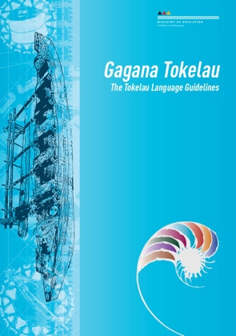
These guidelines offer achievement objectives that are more specific. You could use any of the following level 1 achievement objectives to narrow the focus for your students to help them achieve particular competencies. In selected linguistic and socio-cultural contexts students will:
- recognise and express number, time, and location (1.4)
- express and respond to desires, needs, and preferences (1.7)
- use language, positioning, and movement to show respect (1.8).

(c) Muakiga! An Introduction to Gagana Tokelau
The Unit 9 learning outcomes for students are sharply focused. Students will:
- express their desires, needs, and preferences
- respond to the desires, needs, and preferences of others
- express agreement and disagreement.

Cross-curricular links
Learners who are working at levels 1 and 2 in gagana Tokelau will be working at higher curriculum levels in other learning areas. Here are three examples of cross-curricular achievement objectives that could be linked to this story when you are planning links across curriculum learning areas.

The Arts, Level 3
Dance
Students will:
- explore and describe dances from a variety of cultures
- prepare and share dance movement individually and in pairs or groups.
Music
Students will:
- identify and describe the characteristics of music associated with a range of sound environments,
in relation to historical, social, and cultural contexts.

Social Sciences, Level 3
Students will gain knowledge, skills, and experience to:
- understand how the movement of people affects cultural diversity and interaction in New Zealand.

Values
The story illustrates the values of:
- community and participation for the common good
- respect for themselves and others.
See page 10 in The New Zealand Curriculum.
In addition, students will come to appreciate how the story reflects core Tokelau values of fakaaloalo (respect), māopoopo (inclusion), and vā feāloaki (relating to others). See pages 8–9 in Gagana Tokelau: The Tokelau Language Guidelines.
Effective pedagogy for language teaching
Effective pedagogy research is integrated into these teacher support materials.
The New Zealand Curriculum (pages 34–36) summarises evidence of the kinds of teaching approaches that consistently have an impact on student learning.
Research into second language acquisition pedagogy reviewed in Ellis (2005) establishes ten principles for teacher actions that promote student learning.
Research into intercultural communicative language teaching (Rivers, based on Newton et al. 2010) establishes six principles for a pedagogy that is effective in achieving the outcomes specified in The New Zealand Curriculum.

Language learning activities
Choose or adapt these learning activities to suit your students’ diverse needs and the particular objectives they are to achieve.
Link to prior learning
The students recall their prior learning of gagana Tokelau so that they can read the story and understand it.
The students work in groups to read the story. They share with each other what they think the story
is about. They use the words and expressions listed in the glossary to help them to make meaning from the written text. Each group presents their version of what the story is about to the class.
Project the English version, or hand out copies of it. The students read and reflect on their understandings of the gagana Tokelau text. Give them time to reread the gagana Tokelau text, referencing the English version as they read, so that they can enjoy the story.
Language structures – focus on form
The students develop their knowledge of how gagana Tokelau is organised in particular ways.
Take the theme of “expressing agreement and disagreement”. The students study the written text
and find examples of:
- agreement
- disagreement
- the use of hē to express a negative.
This activity sharpens the students’ recognition of language patterns used to express these ideas.
To highlight this focus, choose some of the language patterns to dictate to your students to develop their writing skills and sound–spelling combinations.

Try these sentence patterns. Say each sentence twice, giving the students enough time to write each sentence in their books.
- “Io, ē hako!” ko te tali atu ia a Telehia. “Te lelei, nī?” [agreement]
- Kua uhu nei te pehe a te mātua tupuna kae fakalogologo ia Whotovalu. [agreement]
- “Ko au e fītā. Ko au nae takalo netipolo ananafi. Tātou nonofo vēnei, nī?” [disagreement]
- Kua hē ia mafaia oi takalo lakapī. [negative]
Project the sentences, or hand out copies of the storybooks for the students to find the sentences,
so that they can correct their own work.
Role-plays – controlled and free production
The students communicate with others in particular situations, and monitor their own skills development.
Unit 9 of Muakiga! (pages 239–240) develops in students the skills to assess their own role-play presentations, using particular assessment criteria.
This activity offers a further opportunity for them to use tasks defined as “controlled production”
and “free production” based on the story. Depending on the level of confidence of your students, choose from the following:
(a) This task is “controlled production”. The students use prescribed content.
Hand out copies of the storybook. Divide the students into groups of seven to role-play the story.
The roles include the six characters in the story and a person to act as narrator. They share out the roles within their group. Give the students time to rehearse their parts to develop their confidence and fluency.
(b) This task is “free production”. The students create their own content.
Divide the students into groups. Each group makes up its own role-plays based on the storybook and any language from Units 1–9 in Muakiga! Alter the numbers of students in the groups, depending on
the scenario the students develop and the number of characters they need. Allow enough time for them to create their role-plays and practise them. This may take several lessons.
Video-record these performances, or get someone else to record them. Show the video to the students for them to assess the performances. Give them time to apply the criteria to their own performances and discuss their assessments with each other.
Sequencing
The students recall their prior learning of gagana Tokelau. They develop their understanding of how
the language is organised in particular ways.
Photocopy (or retype) sentences from page 5 onto card. Cut up the card so that each piece of card has one sentence. Hand out the sets of sentences, one set per pair or group. The students arrange the sentences in sequence, without referring to the storybook. Read the story aloud so that the students can check their sequences. To encourage rapid reading, place a time limit on their assembly task. Repeat this activity using other pages in the storybook.
Songs
The students learn how gagana Tokelau and agānuku Tokelau are organised in particular ways through discussing examples of pehe and the meanings of the songs. They also identify and describe the characteristics of music associated with a range of sound environments, in relation to historical, social, and cultural contexts.
Review the songs you and your students have learned to sing through using Muakiga! Play some other Tokelau songs to your students. Use the Tokelau songs in the print and CD resource Fātuga Faka-Tokelau: Tokelauan Songs [item 31047], some of which were included in Songs to Celebrate Pasifika Languages and Cultures; Songs and Music to Support the Pasifika Learning Languages Series for Years 7 – 10 (Wellington: Ministry of Education, 2010). Or arrange for community members to come
to your class and teach students some Tokelau songs and their meanings.
The students consider these songs and choose one that they would describe as he pehe mālie (a sweet song), giving reasons for their choice.
Presenting information
The students research, explore, and present information on aspects of Tokelau culture and values included in the story.
Possible themes:
- a list of formulaic expressions used in the story, prepared as a poster for the classroom wall for others to refer to and use in appropriate contexts
- the Tokelau Easter Tournament in New Zealand – the different kinds of activities and events
- Easter activities and celebrations in different parts of Tokelau
- the significance of the Tokelau Easter Tournament to the Tokelau communities in
New Zealand, and the values associated with the event
- in-depth research into one kind of event, activity, or genre, for example, hiva fātele, kilikiti,
or pehe, making cross-cultural comparisons, for example, between how kilikiti is played in
Tokelau and Sāmoa
- profile a Tokelau songwriter or artist.
The students use a range of sources to gather their information, for example, the Internet, reference books, and Tokelau community members. They work in pairs or groups. They present their information on posters to the rest of the class.
Viewing and presenting – spoken communication
The students process vocabulary and language structures, develop fluency in speaking, and adapt language to suit their own communicative purposes.
Make photocopied sets of the illustrations in the storybook (minus the written text), one set per group. The students work in groups to share a retelling of the story (narrative and/or conversation) using the illustrations to guide their presentations. Tell them to keep the story simple and use the written text to support the story they develop. Give them time to practise telling their story before they present to the class, to enable them to say their lines fluently.
Record these presentations. Play the recordings so that the students can self-monitor their performances as well as receive others’ feedback about the improvements they need to make.
This feedback may include:
- comment on how well they can be heard (audibility)
- comment on how well they can be understood (pronunciation, stress)
- comment on how well the story makes sense (logical sequence of actions)
- comment on how well the story is presented (fluency, lack of hesitation, no notes).
Writing text
The students write texts with appropriate use of macrons and correct spelling as they communicate
with others in particular situations.
The students write a short story based on the storybook content, as an individual task. They retell the story. Set a sentence limit, for example, ten sentences. They tell the story from the point of view of Whotovalu, in either the first person “I” form, or the third person “he” form.
The students prepare their written text, then hand it to another student to read and comment on.
They then review their own text and prepare their final copy. Display their writing on the classroom
wall. Store copies in your students’ portfolios.
Tokelau culture and the Easter Tournament in New Zealand
This activity helps students to understand how the movement of people affects cultural diversity
and interaction in New Zealand.
The story shows aspects of preparations and performances at a Tokelau Easter Tournament in
New Zealand. The Tournament often caters for 3,000 people or more. Facilitate a discussion with
your students, or set research questions, about the facilities and circumstances that affect the
activities that take place during the Tokelau Easter Tournament. The students explore how the environment influences the kinds of organisation required to host such a large event, and what is offered. The environment includes such issues as the use of locally available materials (food, drinks, materials for costumes), the setting, the buildings, and the climate.
Reflecting on their learning
Help the students to reflect on their learning, and also on how they learn. Students could share these reflections with another student, with a small group of students, or with the whole class. As a prompt, ask the students questions such as:
- What strategies and activities helped you to understand the story?
- What strategies and activities helped you to remember the new language?
- How can you use the new language in other contexts?
- Can you identify aspects of new learning about agānuku Tokelau?
- How have you improved your use of gagana Tokelau?

For example, a student might say:
“I can now tell the story of Whotovalu and the Easter Tournament. Telling the story helped me to say and write new language. I learned some new formulaic expressions in gagana Tokelau. I listened to some Tokelau songs, and chose one I can describe as ‘he pehe mālie’. I know a lot more about the Tokelau Easter Tournament in New Zealand now, and why it is so important to Tokelau people.”

English version of the story
In English, this story by Aloihio Kave Kelemete is:

What a Sweet Song!
page 2
Whotovalu and Telehia were chatting at home. “What date is it today?” asked Whotovalu.
Telehia replied, “It’s the 13th of March. Are you training tomorrow?”
“Yes,” said Whotovalu. “Our team’s playing rugby this Saturday. You know what, only four weeks
to go till the Tournament.”
“Yeah, that’s right!” replied Telehia. “Great, eh?”
page 3
Saturday arrived. The game was almost over. Suddenly, Whotovalu cried, “Ouch, my leg!”
They could hear the cry from the other side of the rugby field. When Telehia looked over she saw her brother sitting on the ground. How awful! He’d broken his leg!
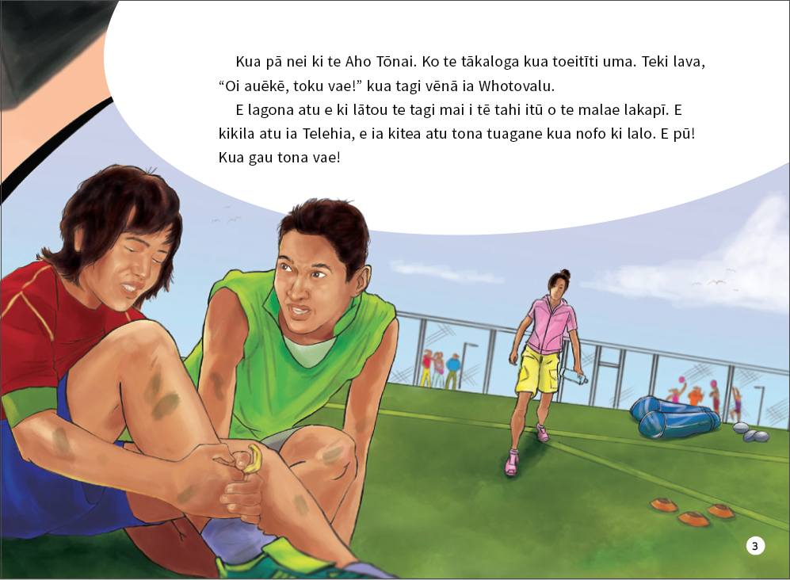
The above page:
Text and illustration copyright © Crown
page 4
On Wednesday, Telehia and her parents were getting ready to go to dance practice. Whotovalu
was lying on the sofa in the lounge. He was bored.
“My poor son” said his mum. “Stay here with your nena. We’ll be back soon.”
“Bye, everyone,” said Whotovalu. “Have a good time!” Whotovalu was feeling sad. He couldn’t
play rugby. He couldn’t dance.
page 5
His grandmother came into the room, singing. She was always singing. She sang sweet songs. “Hey, why are you so sad?” she asked Whotovalu.
Whotovalu replied, “I like to dance. I like to play rugby, too. But look at my leg,” he said.
“There are three weeks to go till the Tournament, but I can’t dance and I can’t run!”
His grandmother replied, “So what are you going to do about it?”
page 6
Whotovalu thought about it. Then he had an idea. “Hmm, Nena, what’s that song you’re
always singing?”
His grandmother sang the song while Whotovalu listened.
“Nena, that’s a sweet song. I have an idea. You could sing your song at the concert, and I could play my guitar. How about it? Would you please teach me the song?” asked Whotovalu. “And don’t tell the others we’re learning a song, OK? It’ll be a surprise for everyone.”
page 7
In the remaining weeks leading up to the Tournament, Telehia and her parents went to the training and dance practices, while Whotovalu and his nena practised their song at home. Soon it was Easter. Everyone gathered for the Tournament. They came together from many different places.
page 8
On Saturday afternoon, they all got together to watch the rugby. Whotovalu watched his father play. His team won. He watched his friends play. Their team won. He felt sad because he wasn’t playing.
page 9
On Saturday evening, they all went together to the dancing. Whotovalu watched Telehia and
his mother dance in their group. They both danced well. Everyone clapped for a long time. He felt
sad because he wasn’t dancing.
page 10
On Sunday evening, Whotovalu called out to his family, “Come, let’s go and watch the concert together.”
Telehia replied, “I’m tired. I played netball yesterday. Let’s stay here, OK?”
His dad said, “I’m tired, I played a lot of rugby yesterday. Let’s stay here, OK?”
His mum replied, “I’m tired. I was dancing last night. Let’s stay here, OK?”
The above page:
Text copyright © Crown
page 11
“No! Come on, let’s go now, the concert’s about to start!” growled Nena.
“OK,” said Telehia, “Let’s go then!”
Nena looked at Whotovalu and laughed. They all went off to the concert.
page 12
“This is the final item in tonight’s concert,” announced the M.C. “The item is called ‘A Sweet Song’. Please put your hands together …”
Whotovalu and Nena appeared on the stage. Nena sang beautifully. Whotovalu played the
guitar beautifully.
“Lovely!” called out Telehia.
Everyone clapped for a long time. Hey, what a sweet song!
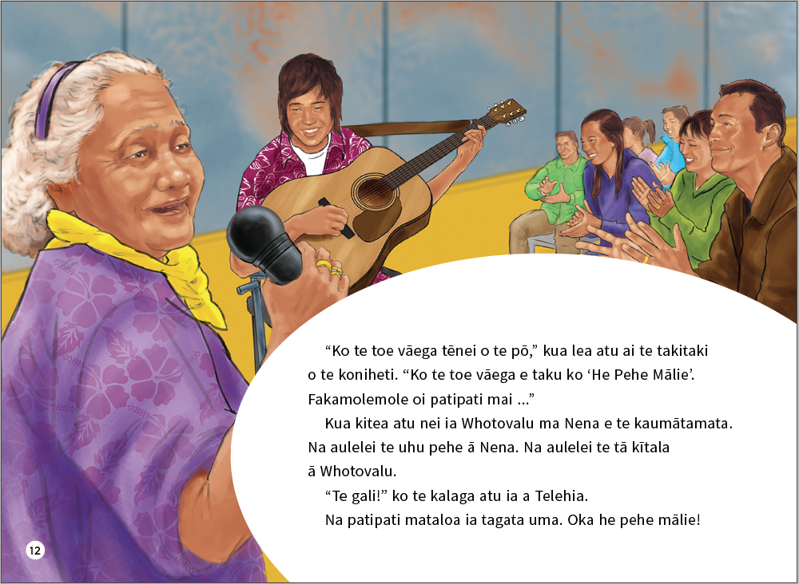

ISBN 978-1-77669-694-9 (WORD)
ISBN 978-1-77669-695-6 (PDF)
The above page:
Text and illustration copyright © Crown

Newton, J., Yates, E., Shearn, S., and Nowitzki, W. (2009). Intercultural Communicative Language Teaching: Implications for Effective Teaching and Learning. Wellington: Ministry of Education.

